
East West University
Department of Computer Science and Engineering

Course: CSE251 Electronic Circuits
Expt No.: 7
Title: Biasing of a Common-Source Voltage Amplifier

Objectives:
- Identify an appropriate DC operation point for a NMOS transistor.

Theory: The common-source amplifier with a NMOS transistor is shown here.
- The biasing is done by fixing the gate voltage with a voltage divider and also by using a source resistor R_{S}. The source resistor gives negative feedback and stabilizes the bias current as a function of temperature variations and transistor characteristics. This is a popular biasing scheme for discrete transistor circuits.
- Select source resistor such that voltage Vs at source terminal is about 1/3rd to 1/5th of V_{DD}. The resistance R_{D} is chosen such that drain voltage V_{D} is about in the middle of V_{DD} and V_{S}. This is done so that the signal at the drain has a relatively large and symmetrical output swing.
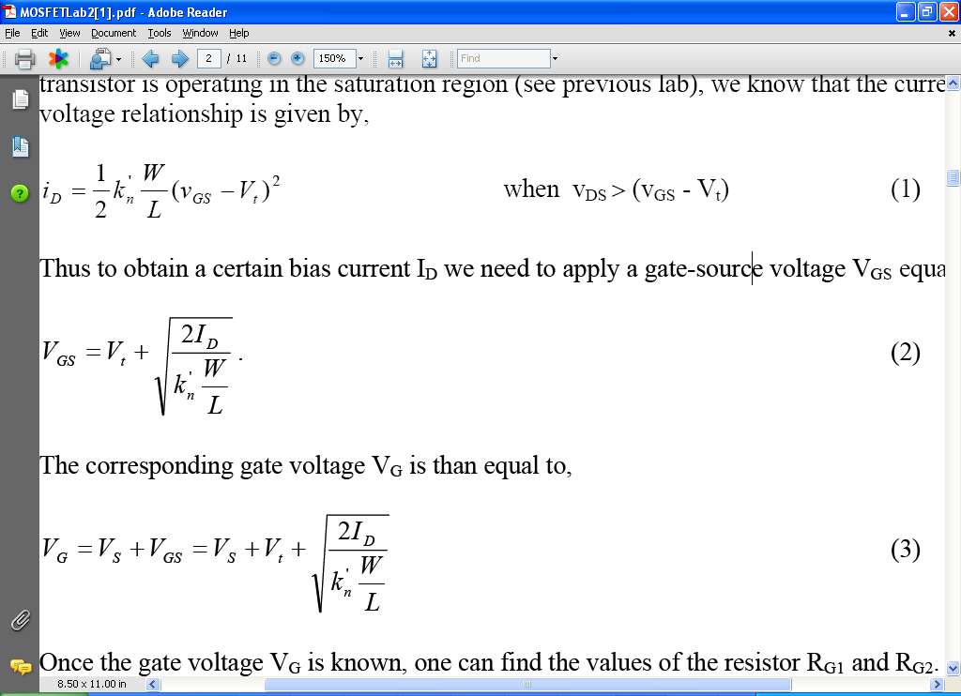
- We choose the resistors such that the parallel resistor is relatively large to ensure a large input resistance of the amplifier and prevent loading of the signal source R_{in}=R_{G1}||R_{G2}.
- An important characteristics of a transistor is its transconductance g_{m} . It is a measure of the rate of change of output current with respect to input voltage v_{gs}. The g_{m} can be written as follows,
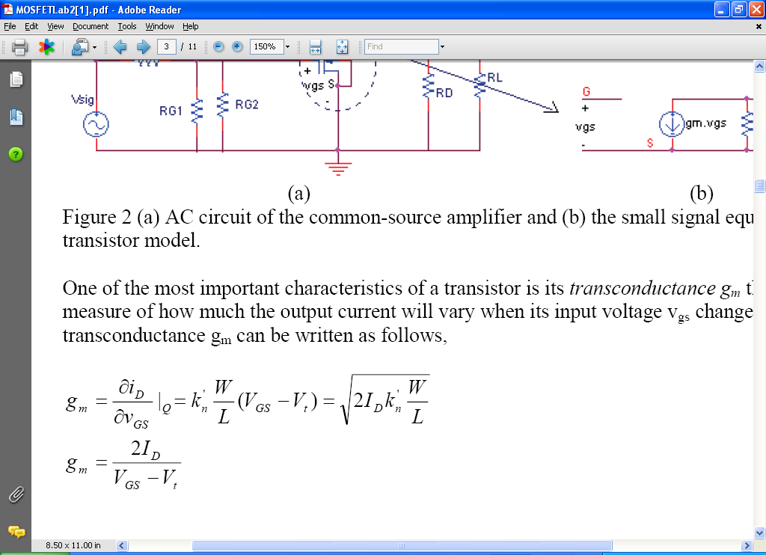,

Circuit Diagram:
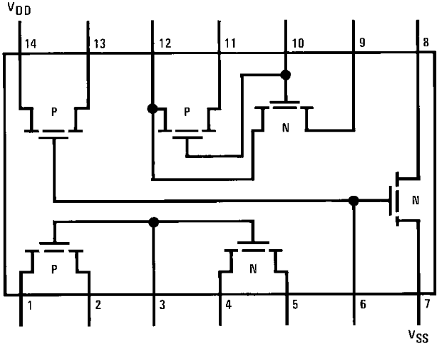
Figure 1. Pin diagram of CD4007C IC.

Equipments and Components Needed:
- Digital trainer board
- DC power supply
- Digital multimeter
- DC Voltmeter
- CD4007C IC (1 pc)
- Resistor (1KΩ 1 pc)
- Breadboard
- Connecting wires

Lab Procedure:
Pre-Lab:

- Read: Section 4.5.2 (example 4.9) Sedra-Smith, 5th ed.
- You have to bias the transistor with a bias current I_{D} = 0.6mA. Let the source voltage V_{S} be 4V.
- Choose drain voltage V_{D} such that it is in the middle of V_{Sn} and V_{DD.}
- The input resistance R_{G} should be larger than 15 kOhm.
- The NMOS transistor (CD4007CN array) characteristics are: V_{t}= 1.2V , k_{n}’W/L=0.7mA/V²,
- Following example 4.9 procedure and information above determine the value of V_{D}, R_{S}, and R_{D}, R_{G1} and R_{G2}
- What is the total DC power dissipation in the amplifier? (hint: power dissipation is V_{DD}I_{total}).
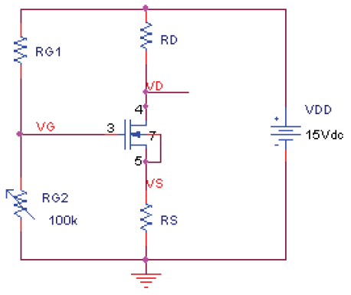
PROCEDURE:
In this part you will bias the transistor (Figure to the right) using pre-lab data.

- Build the circuit to the right. Use the transistor between the pins 3, 4 and 5. Connect the pin 7 source (pin 5) of the NMOS transistor; drain-to-source short is done to eliminate the back-gate (body) effect on the threshold voltage. (If this transistor does not work try any of the other two NMOSes). For the biasing resistor R_{G2}, use a 100 kOhm pot. For R_{G1}, R_{D} and R_{S} use the values from pre-lab.
- Set the pot R_{G2} such that the drain voltage V_{D} (pin 4 of MOSFET) is between 9 and 10 V. Note the drain voltage V_{D}=___V. Now measure the gate and source voltages. V_{G}=___V. V_{S}=___V. Calculate the drain current I_{D =} ___A?

